Ethan Allen Pink Panther’s Virtue

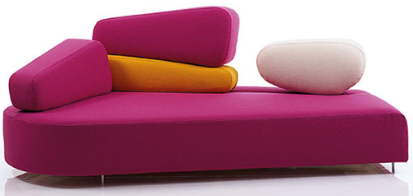

|  |
| --- |
| **DESCRIPTION** |
| Pink Panther’s Virtue Sofa produced by Ethan Allen, presents a sleek, Pink design that is both Supporting and very comfortable. The wide Range of cushions adjusts according to the spinal cord slim cylindrical legs on bottom provide stability for the sofa. High pressure with less area applied to the ground keeps the sofa balanced. Round increased cushion gives more space for the user to relax and achieve his comfort target. |

|  |  |  |
| --- | --- | --- |
| **Price** | **2935$** | |
| **Dimensions** | **H** x **W** x **L** | **35in x 32in x 54in** |
| **Features** | **Four cushion in which two pink one yellow and other white is include which are reattach able by formed thread.** | |
| **Finished** | **Sophisticated Form** | |
| **Available in** | **Pink Only** | |